FOR IMMEDIATE RELEASE
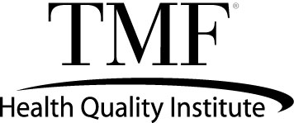

TMF to Present at National Quality Conference on

the Use of Data to Advance Health Equity

Bethany Gabbard, PhD, TMF’s Senior Data Analyst to Present

Austin, Texas – April 27, 2023 – TMF Health Quality Institute senior data analyst, Bethany Gabbard, PhD, will join other experts from across the country in a panel presentation Monday, May 1, at 3:10 p.m. ET to discuss the use of data dashboards and interactive tools to identify and address health disparities.

TMF, as a Centers for Medicare & Medicaid Services (CMS) Quality Innovation Network-Quality Improvement Organization (QIN-QIO), works with health care providers across the spectrum of health care to improve the quality of care for patients. In this session at the 2023 CMS Quality Conference, Dr. Gabbard and fellow panelists will discuss the QIN-QIO efforts to advance health equity using customized data dashboards and interactive tools to assess relationships across equity measures and social determinates of health.

For more information, visit the 2023 CMS Quality Conference website.

About TMF Health Quality Institute
TMF Health Quality Institute focuses on improving lives by improving the quality of health care through contracts with federal, state and local governments, as well as private organizations. For more than 50 years, TMF has helped health care providers and practitioners in a variety of settings improve care for their patients. Visit www.tmf.org for more information.
Media Contact:
Emilie Fennell
Director, Communications and External Relations
TMF Health Quality Institute
512-334-1649
emilie.fennell@tmf.org

